SQL DATABASE PROJECTS

CREATION OF MY OWNN DATABASES AND APPLYING QUERIES ON THEM

1. MYSQL

1. Creating a table of company data: company employees, name, surename, salary, position, etc: (companies_data dataset)

MySQL:

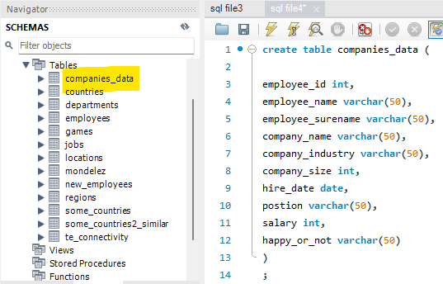

2. Let’s see if the table is properly created (companies_data dataset)

MySQL:
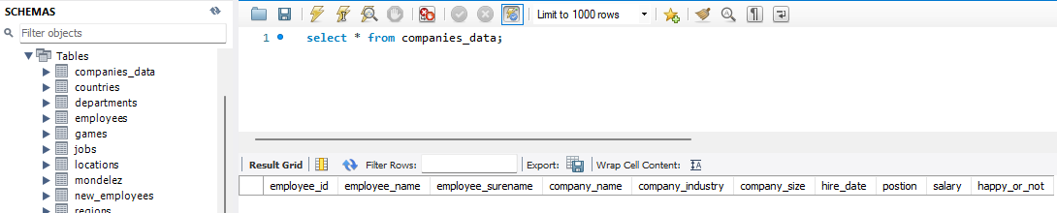

3. Adding a few data lines to the table. (companies_data dataset)

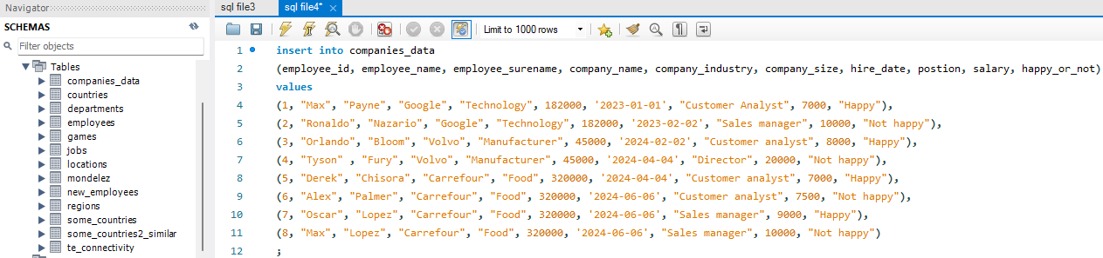
MySQL:

4. Checking how the table looks now. (companies_data dataset)

MySQL:

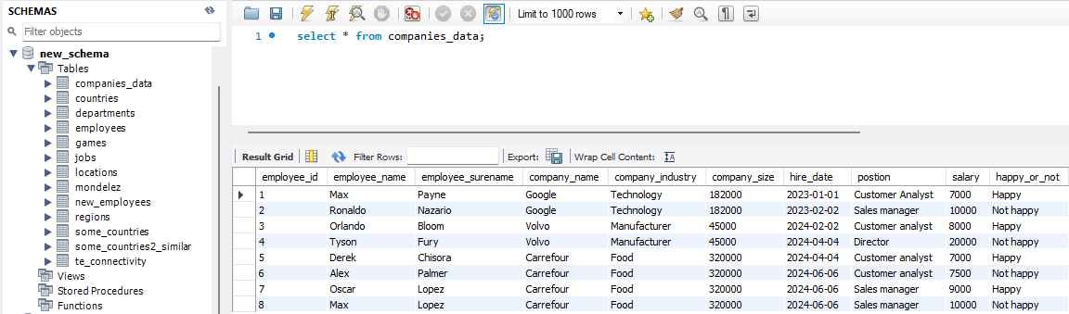

5. Getting all data sorted by name (employees dataset)

MySQL:

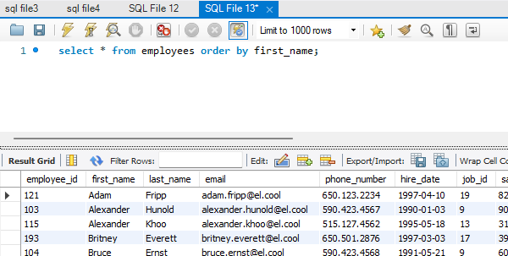

6. Getting data for all employees in Google. (companies_data dataset)

MySQL:

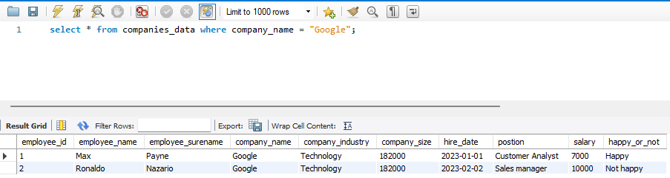

7. Getting data from all Customer analysts. (companies_data dataset)

MySQL:

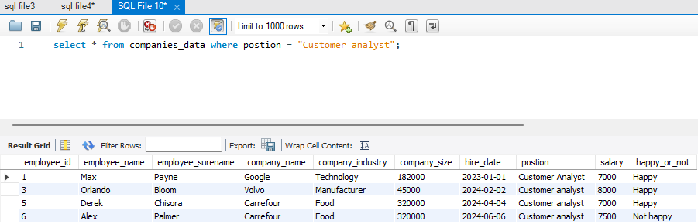

8. Data for employess with salary less than 8000. (companies_data dataset)

MySQL:

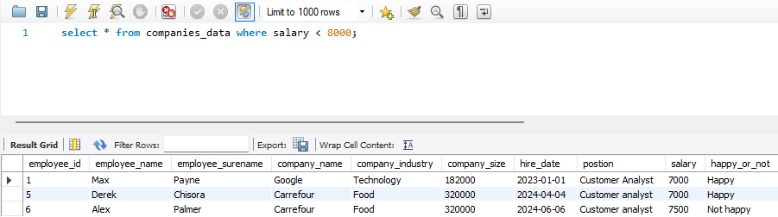

9. Data for all employees that are happy and their salay is between 7000 and 8000. (companies_data dataset)

MySQL:

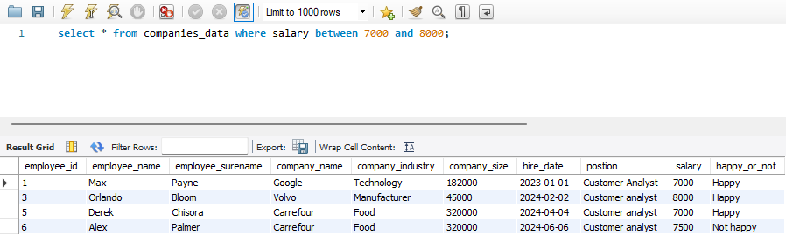

Write a query to display the names (first_name, last_name) using alias name "First Name", "Last Name" (companies_data dataset)

MySQL:

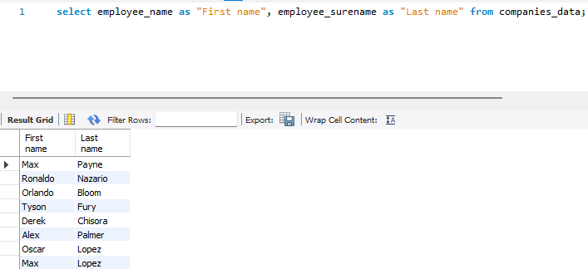

Write a query to get unique department ID from employee table. (employees_data dataset)

Write a query to get all employee details from the employee table order by first name, descending. (employees_data dataset)

Write a query to get the names (first_name, last_name), salary, PF of all the employees (PF is calculated as 15% of salary). (companies_data dataset)
MYSQL:

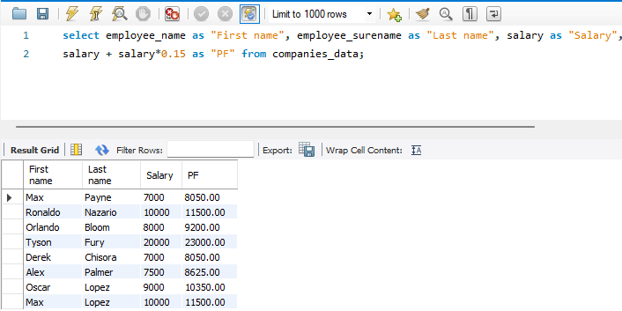

Write a query to get the employee ID, names (first_name, last_name), salary in ascending order of salary. (companies_data dataset)
MYSQL:
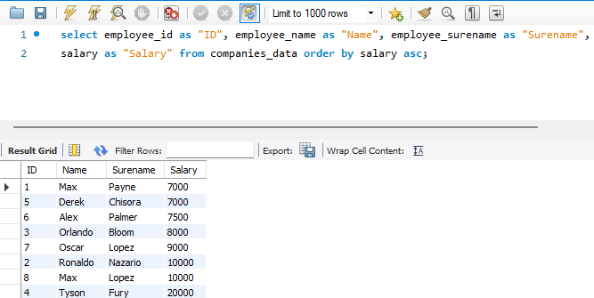

Write a query to get the total salaries payable to employees.
(companies_data dataset)
MYSQL:
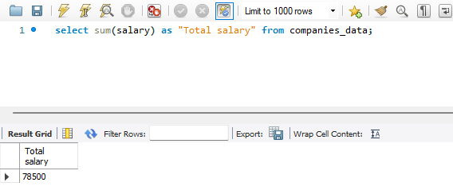

Write a query to get the maximum and minimum salary from employees table. (employees_data dataset)
MYSQL:
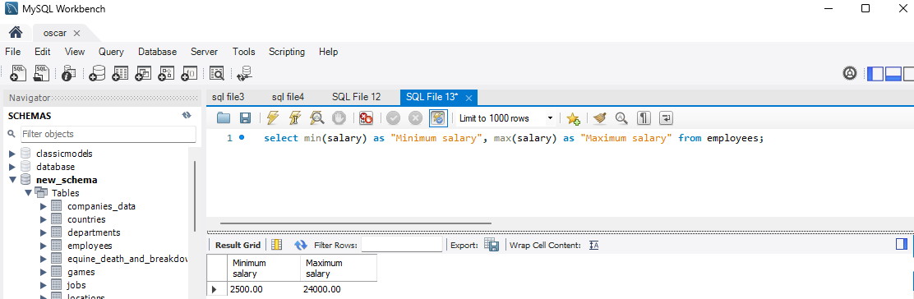

Write a query to get the average salary and number of employees in the employees table. (employees_data dataset)
MYSQL:
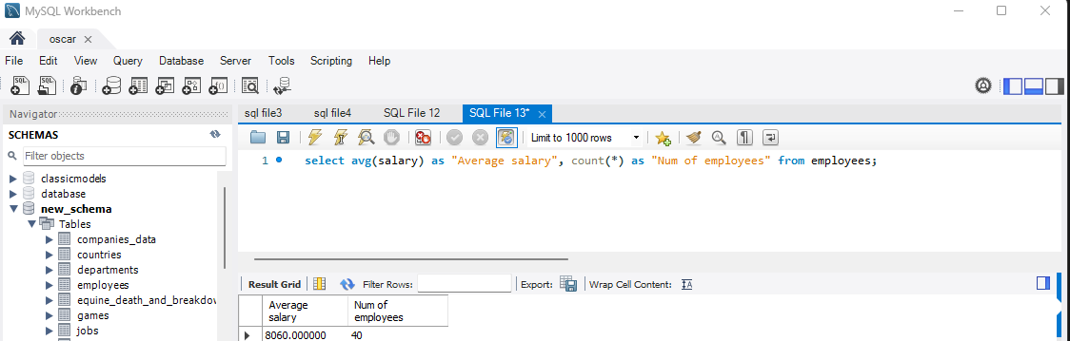

Write a query to get the number of employees working with the company. (employees_data dataset)
MYSQL:
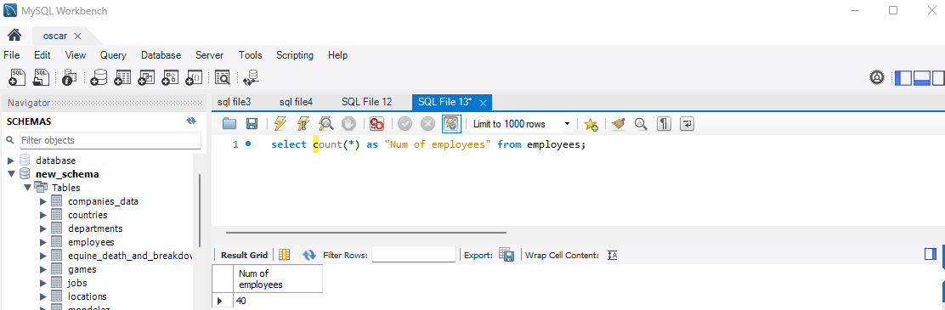

Write a query to get the number of jobs available in the employees table. (employees_data dataset)
MYSQL:
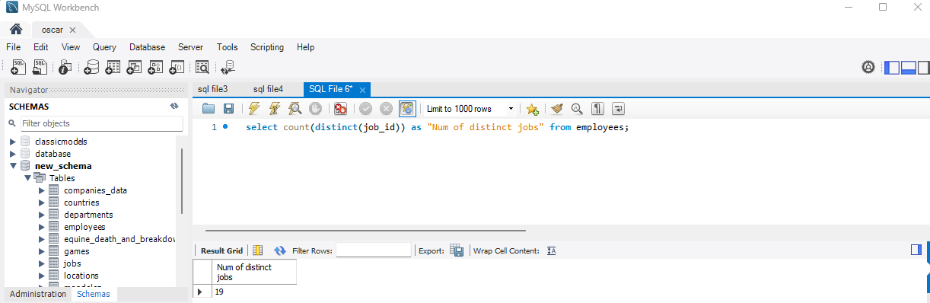
Write a query get all first name from employees table in upper case. (employees_data dataset)
MYSQL:

Write a query to get the first 3 characters of first name from employees table. (employees_data dataset)
MYSQL:

Write a query to calculate 171*214+625. (employees_data dataset)

MYSQL:

Write a query to get the names (for example Ellen Abel, Sundar Ande etc.) of all the employees from employees table. (employees_data dataset)
MYSQL:
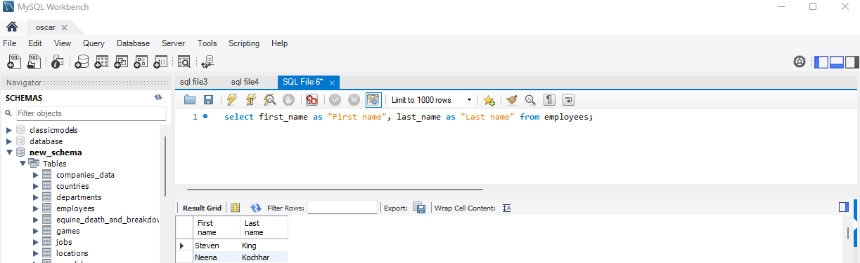

Write a query to get first name from employees table after removing white spaces from both side. (employees_data dataset)
MYSQL:

Write a query to get the length of the employee names (first_name, last_name) from employees table. (employees_data dataset)
MYSQL:
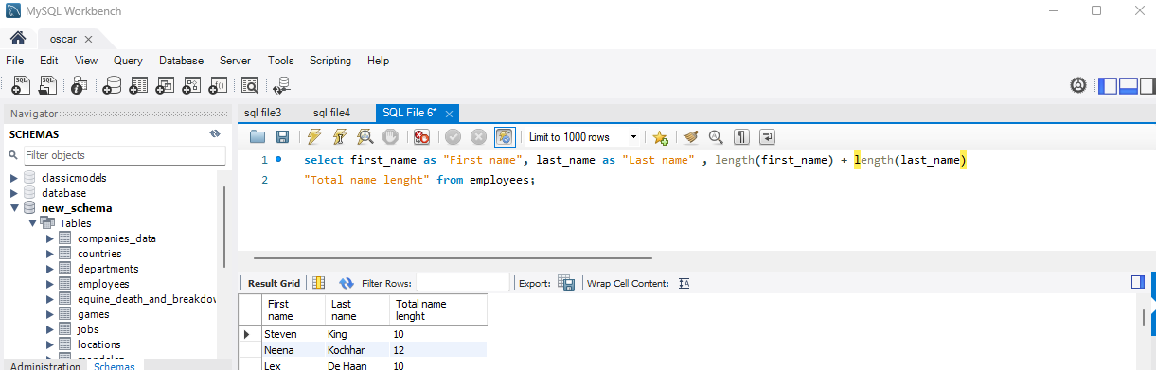

Write a query to check if the first_name fields of the employees table contains numbers. (employees_data dataset)
MYSQL:

Write a query to select first 3 records from a table. (employees_data dataset)

MYSQL:
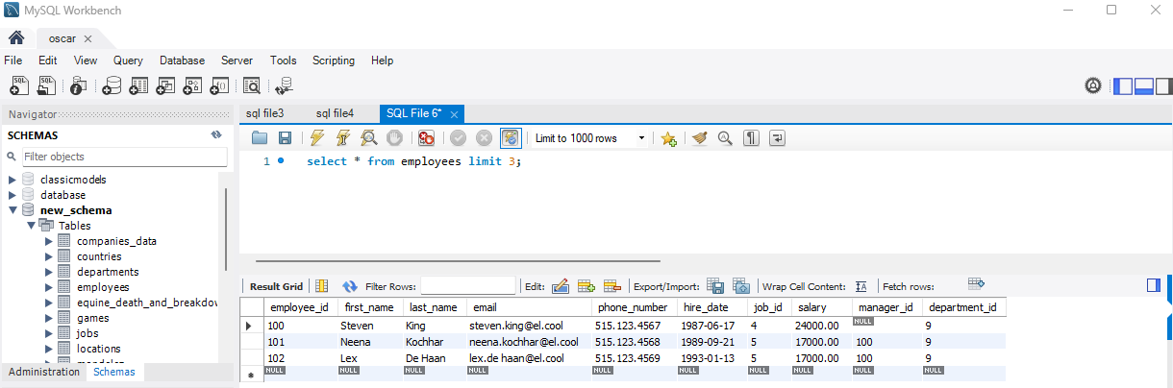

Write a query to get monthly salary (round 2 decimal places) of each and every employee (employees_data dataset)
Note : Assume the salary field provides the 'annual salary' information.

MYSQL:

MySQL Restricting and Sorting data: [11 exercises with solution]
https://www.w3resource.com/mysql-exercises/restricting-and-sorting-data-exercises/

1. Write a query to display the name (first_name, last_name) and salary for all employees whose salary is not in the range $10,000 through $15,000.
Sample table: (employees_data dataset)

MYSQL:
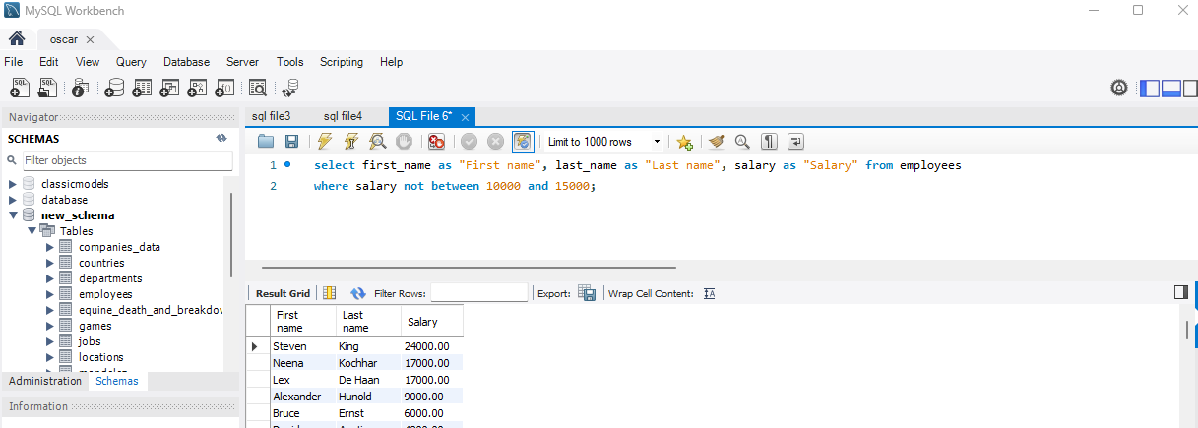

2. Write a query to display the name (first_name, last_name) and department ID of all employees in departments 30 or 100 in ascending order.
Sample table: (employees_data dataset)

MYSQL:
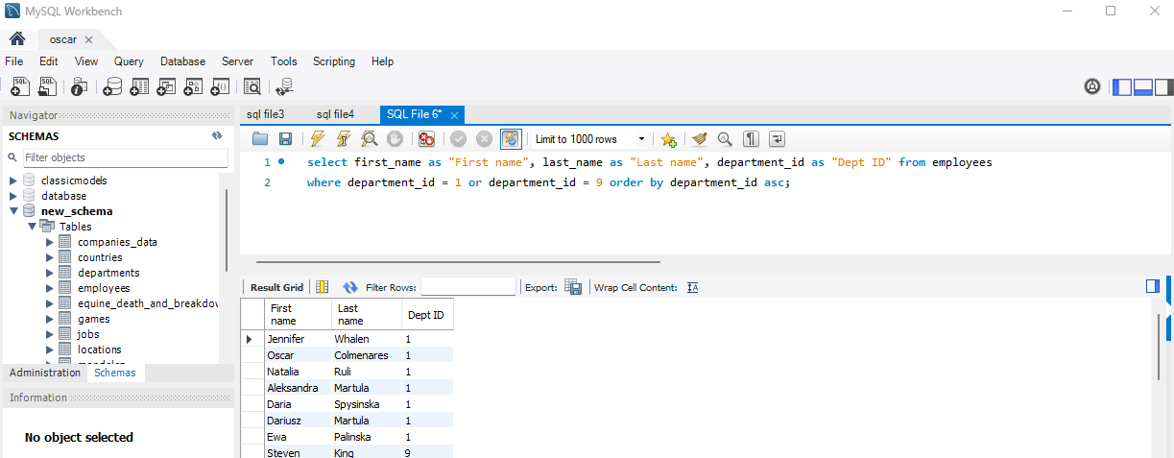

3. Write a query to display the name (first_name, last_name) and salary for all employees whose salary is not in the range $10,000 through $15,000 and are in department 30 or 100.
Sample table: (employees_data dataset)

MYSQL:
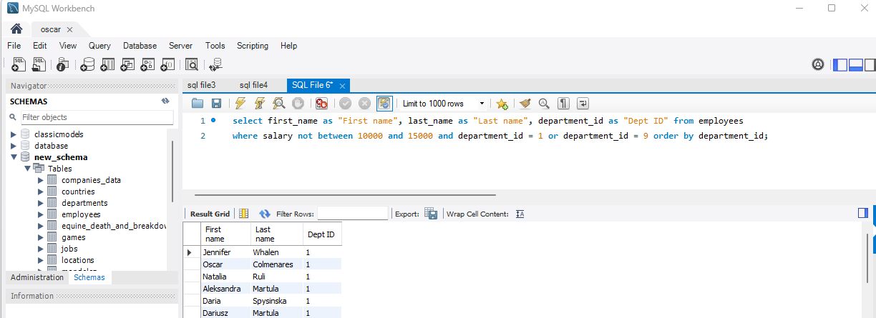

4. Write a query to display the name (first_name, last_name) and hire date for all employees who were hired in 1987.
Sample table: (employees_data dataset)

MYSQL:
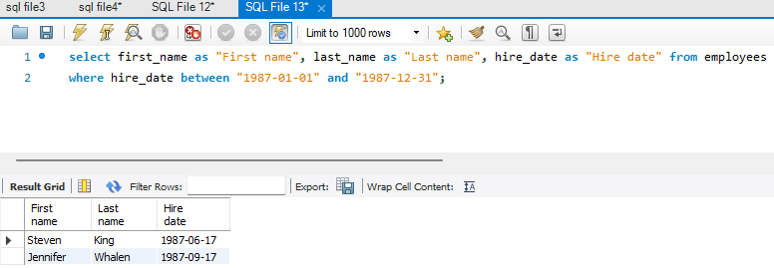

5. Write a query to display the first_name of all employees who have both "b" and "c" in their first name.
Sample table: (employees_data dataset)

MYSQL:
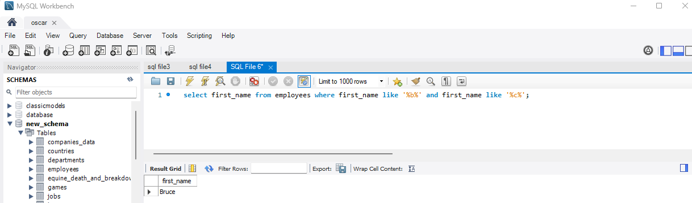

6. Write a query to display the last name, job, and salary for all employees whose job is that of a Programmer or a Shipping Clerk, and whose salary is not equal to $4,500, $10,000, or $15,000.
Sample table: (employees_data dataset)

MYSQL:
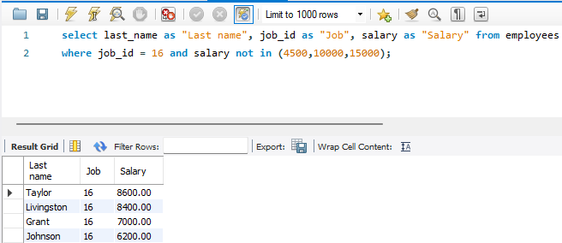

7. Write a query to display the last name of employees whose names have exactly 6 characters.
Sample table: (employees_data dataset)
MYSQL:
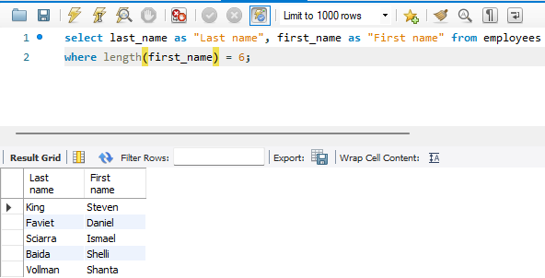

8. Write a query to display the last name of employees having 'e' as the third character.
Sample table: (employees_data dataset)
MYSQL:

9. Write a query to display the jobs/designations available in the employees table.
Sample table: (employees_data dataset)

MYSQL:
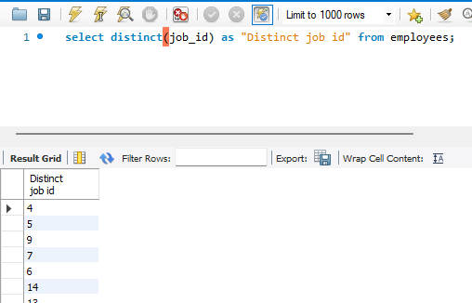

10. Write a query to display the name (first_name, last_name), salary and PF (15% of salary) of all employees.
Sample table: (employees_data dataset)

MYSQL:
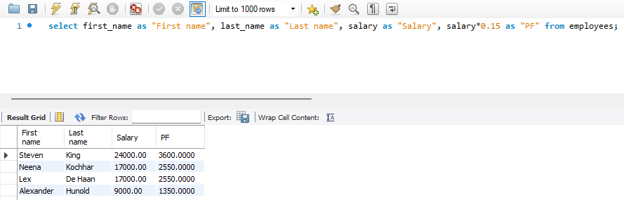

MySQL Aggregate Functions and Group by- Exercises, Practice, Solution
https://www.w3resource.com/mysql-exercises/aggregate-function-exercises/

1. Write a query to list the number of jobs available in the employees table.
Sample table: (employees_data dataset)

MYSQL:
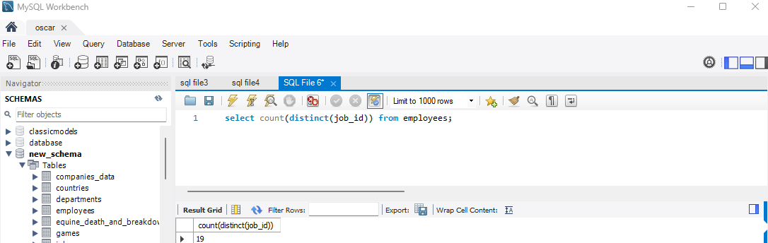

2. Write a query to get the total salaries payable to employees.
Sample table: (employees_data dataset)
MYSQL:
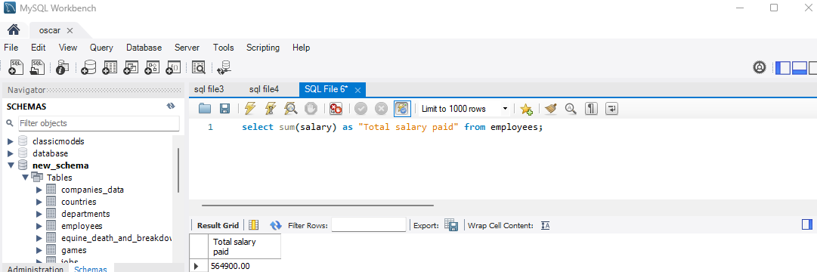

3. Write a query to get the minimum and maximum salary from employees table.
Sample table: (employees_data dataset)
MYSQL:
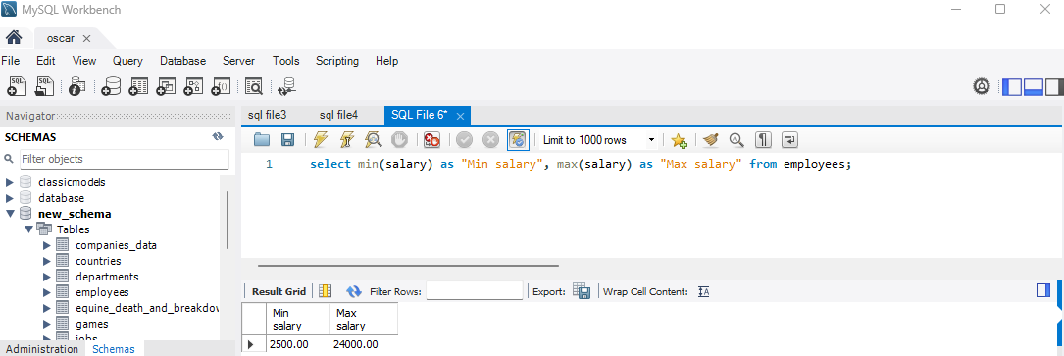

4. Write a query to get the maximum salary of an employee working as a Programmer.
Sample table: (employees_data dataset)
MYSQL:
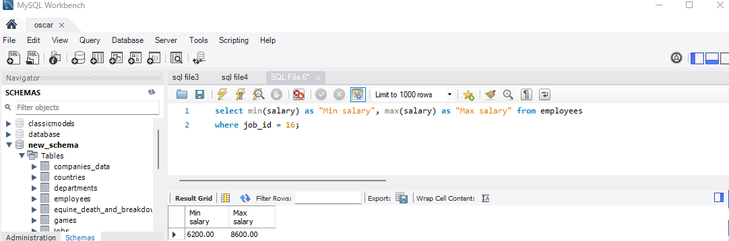

5. Write a query to get the average salary and number of employees working the department 8.
Sample table: (employees_data dataset)

MYSQL:
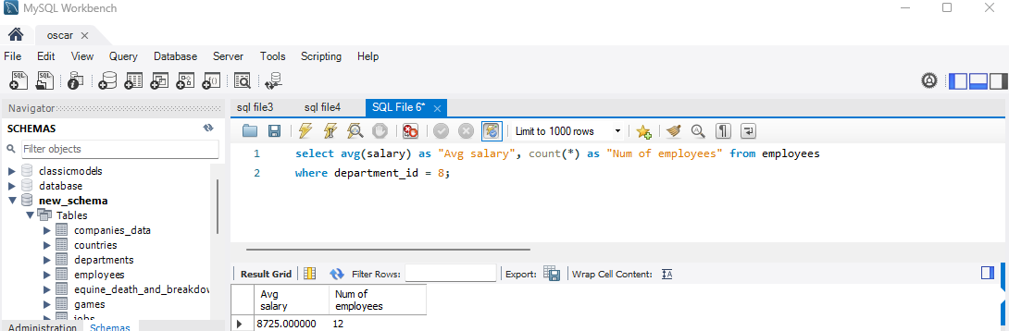

6. Write a query to get the highest, lowest, sum, and average salary of all employees.
Sample table: (employees_data dataset)
MYSQL:
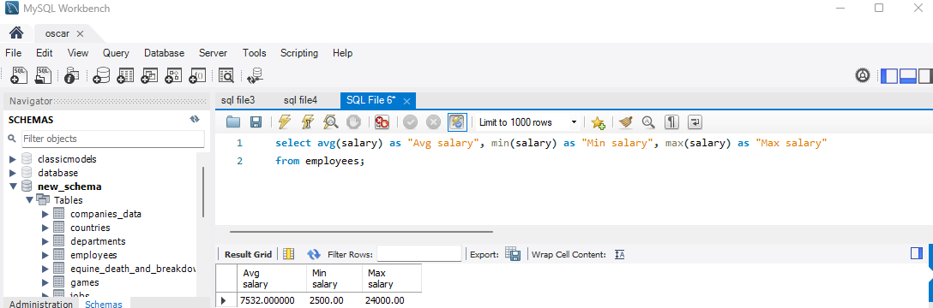

7. Write a query to get the number of employees with the same job.
Sample table: (employees_data dataset)
MYSQL:
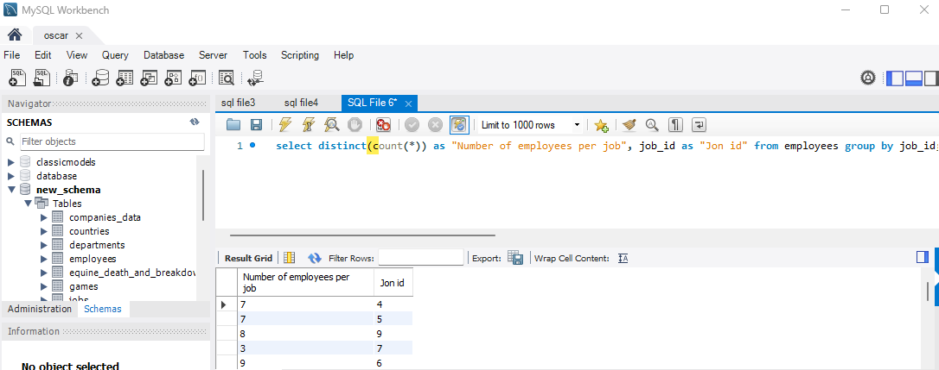

8. Write a query to get the difference between the highest and lowest salaries.
Sample table: (employees_data dataset)
MYSQL:
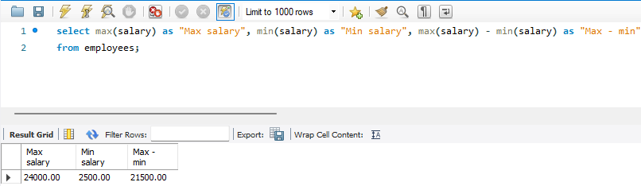

9. Write a query to find the manager ID and the salary of the lowest-paid employee for that manager.
Sample table: (employees_data dataset)
MYSQL:

10. Write a query to get the department ID and the total salary payable in each department.
Sample table: (employees_data dataset)

MYSQL:
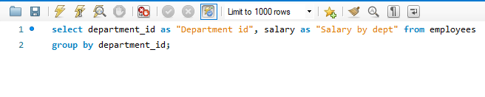

11. Write a query to get the average salary for each job ID excluding programmer.
Sample table: (employees_data dataset)

MYSQL:

12. Write a query to get the total salary, maximum, minimum, average salary of employees (job ID wise), for department ID 90 only.
Sample table: (employees_data dataset)

MYSQL:
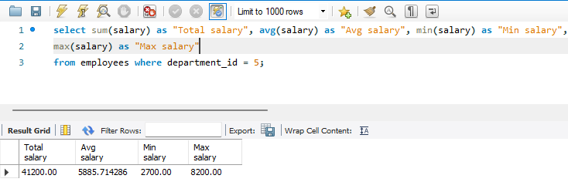

13. Write a query to get the job ID and maximum salary of the employees where maximum salary is greater than or equal to $4000.
Sample table: (employees_data dataset)

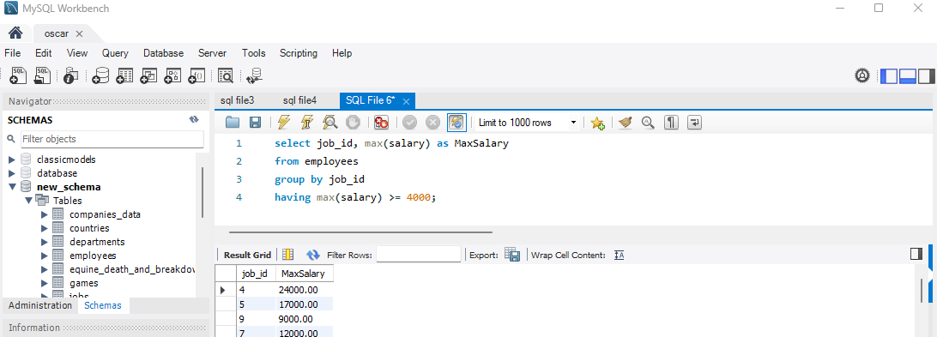
MYSQL:

14. Write a query to get the average salary for all departments.
Sample table: (employees_data dataset)

MYSQL:
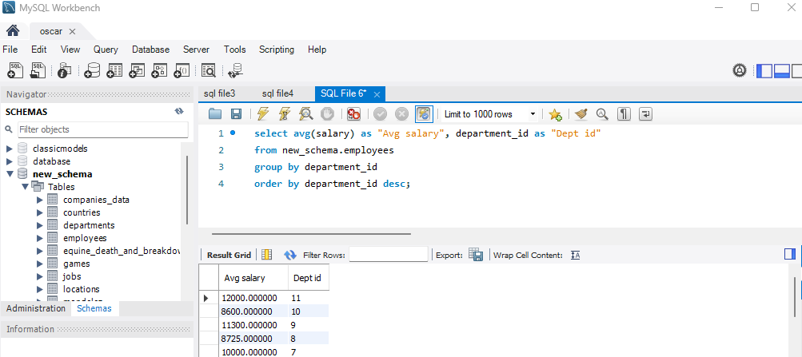

MySQL Subquery - Exercises, Practice, Solution
https://www.w3resource.com/mysql-exercises/subquery-exercises/

1. Write a MySQL query to find the name (first_name, last_name) and the salary of the employees who have a higher salary than the employee whose last_name='Martula'.
Sample table: (employees_data dataset)

MYSQL:
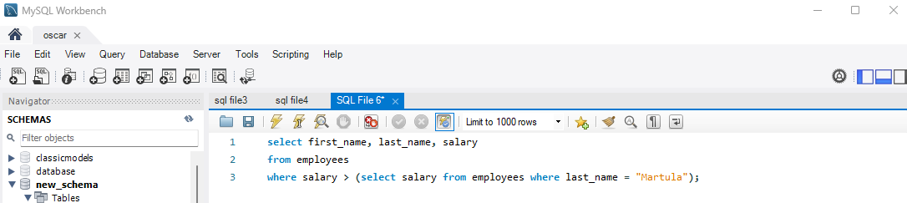

2. Write a MySQL query to find the name (first_name, last_name) of all employees who works in the IT department.(6)
Sample table: (employees_data dataset)

MYSQL:
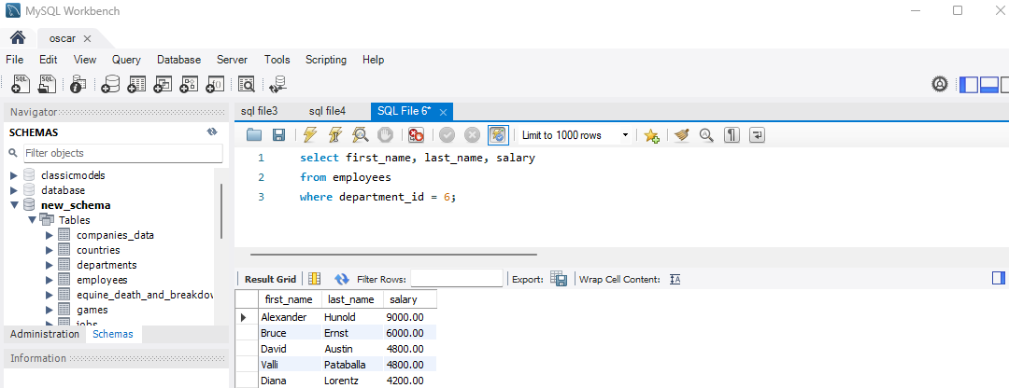

4. Write a MySQL query to find the name (first_name, last_name) of the employees who are managers.
Sample table: (employees_data dataset)

MYSQL:
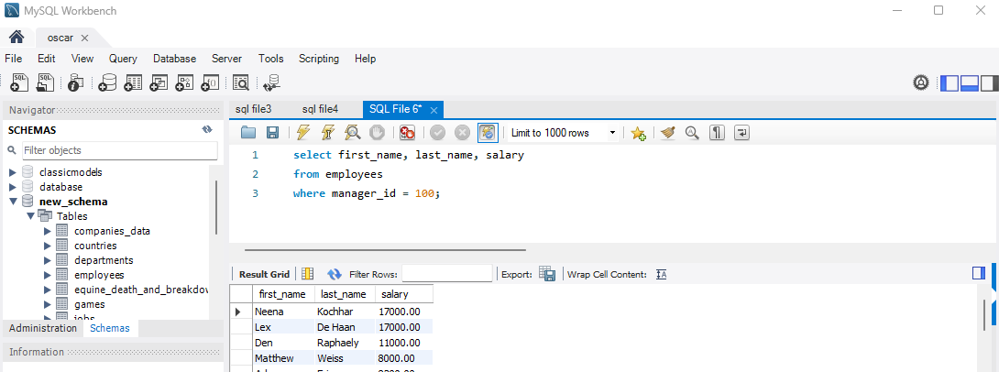

5. Write a MySQL query to find the name (first_name, last_name), and salary of the employees whose salary is greater than the average salary.
Sample table: (employees_data dataset)

MYSQL:
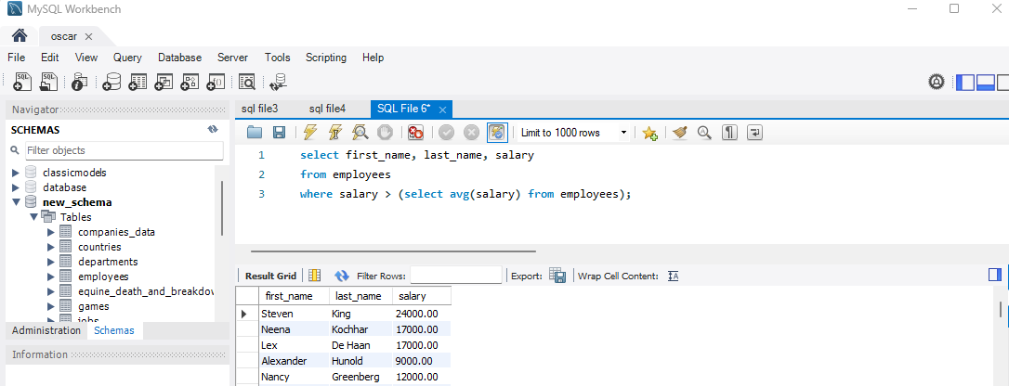

6. Write a MySQL query to find the name (first_name, last_name), and salary of the employees whose salary is equal to the minimum salary for their job grade.
Sample table: (employees_data dataset)

MYSQL:
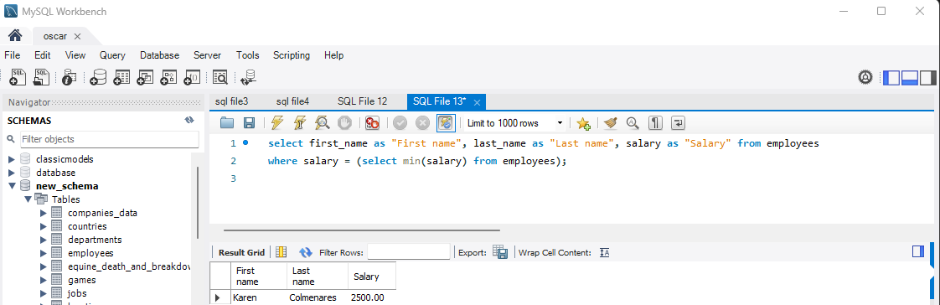

7. Write a MySQL query to find the name (first_name, last_name), and salary of the employees who earns more than the average salary and works in any of the IT departments.
Sample table: (employees_data dataset)

MYSQL:
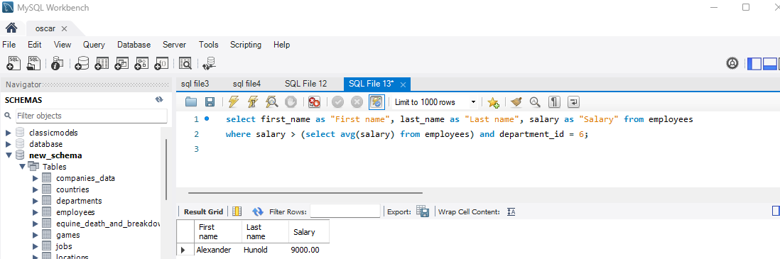

8. Write a MySQL query to find the name (first_name, last_name), and salary of the employees who earns more than the earning of Mr. Hunold.
Sample table: (employees_data dataset)

MYSQL:
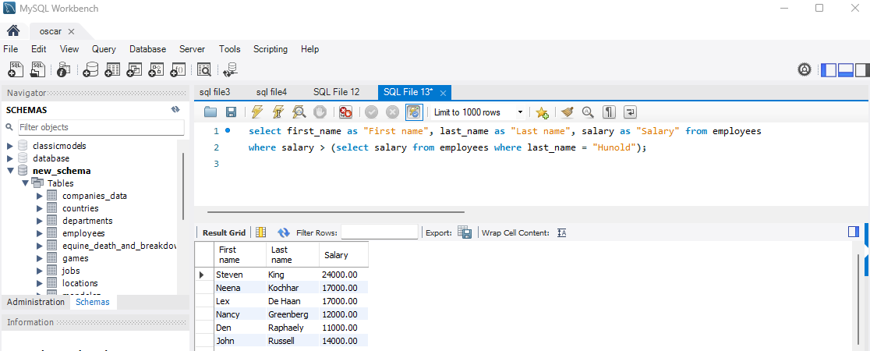

9. Write a MySQL query to find the name (first_name, last_name), and salary of the employees who earn the same salary as the minimum salary for all departments.
Sample table: (employees_data dataset)

MYSQL:
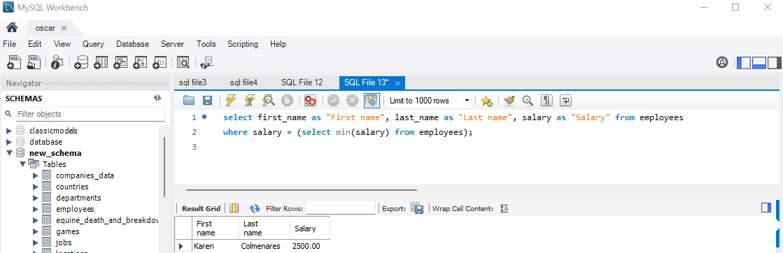

10. Write a MySQL query to find the name (first_name, last_name), and salary of the employees whose salary is greater than the average salary of all departments.
Sample table: (employees_data dataset)

MYSQL:
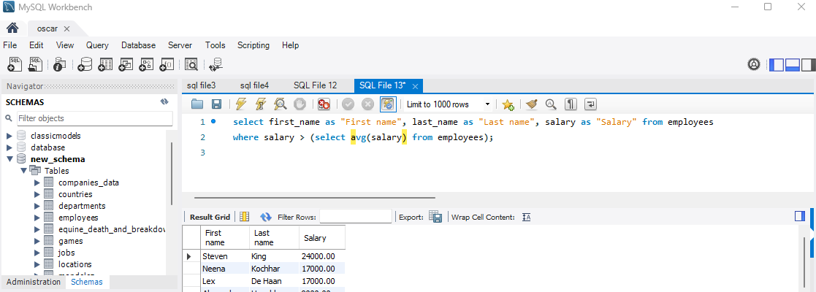

11. Write a MySQL query to find the name (first_name, last_name) and salary of the employees who earn a salary that is higher than the salary of Employee with ID=103. Sort the results of the salary of the lowest to highest.
Sample table: (employees_data dataset)

MYSQL:

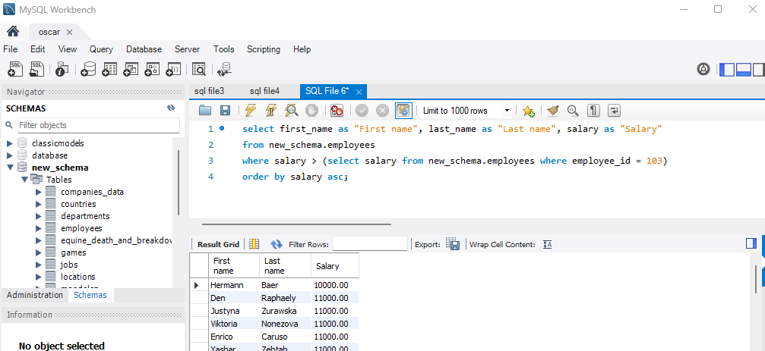

12. Write a MySQL query to find the name (first_name, last_name) of the employees who are not sales managers
Sample table: (companies_data dataset)

MYSQL:
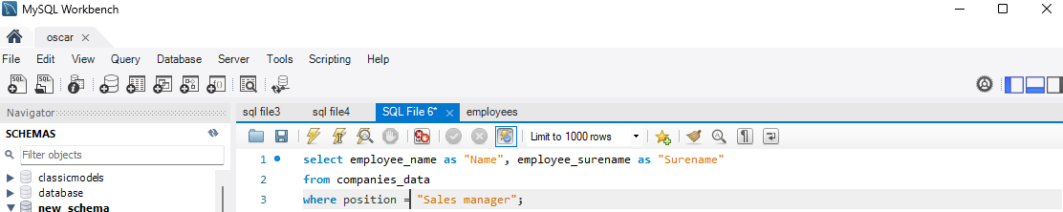

13. Write a MySQL query to display the employee ID, first name, last name, and department names of all employees.
Sample table: (employees_data dataset)

MYSQL:
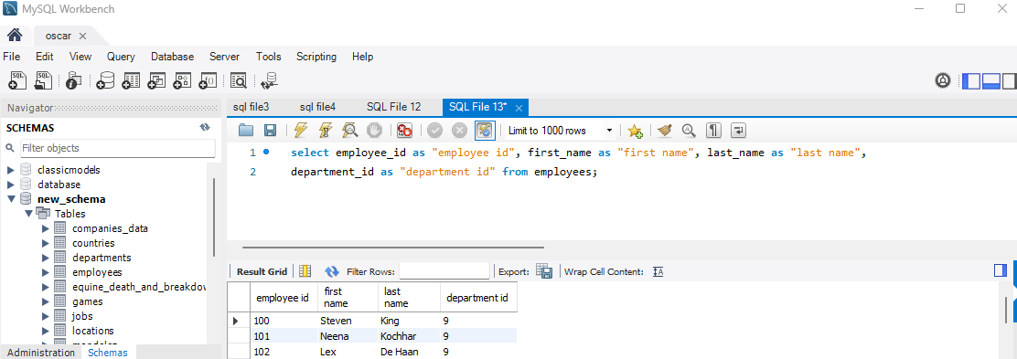

14. Write a MySQL query to display the employee ID, first name, last name, salary of all employees whose salary is above average for their departments.
Sample table: (employees_data dataset)

MYSQL:
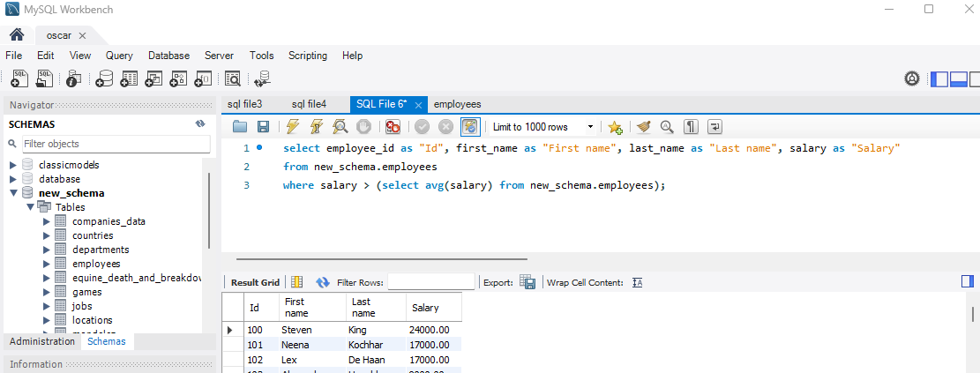

16. Write a MySQL query to find the 5th maximum salary in the employees table.
Sample table: (employees_data dataset)

MYSQL:
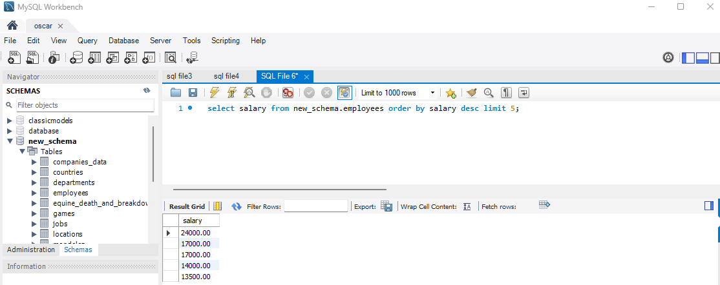

17. Write a MySQL query to find the 4th minimum salary in the employees table.
Sample table: (employees_data dataset)

MYSQL:
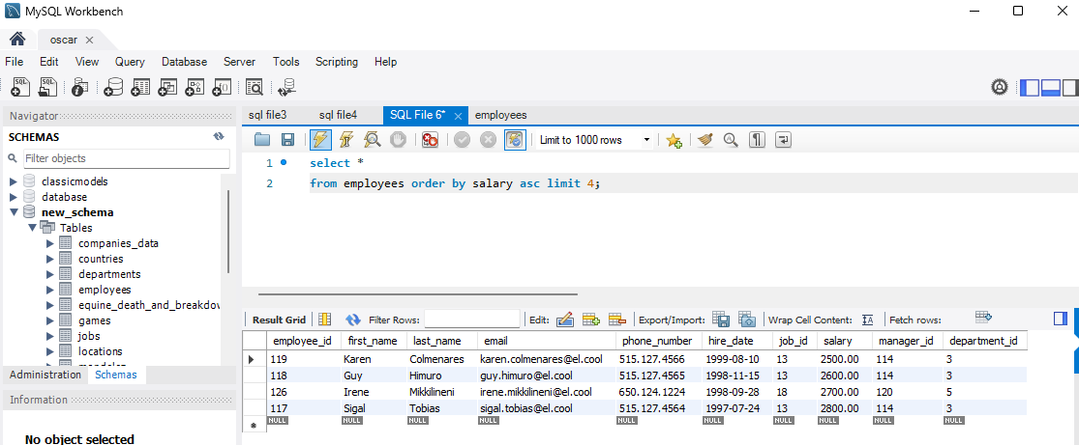

18. Write a MySQL query to select last 5 records from a table.
Sample table: (employees_data dataset)
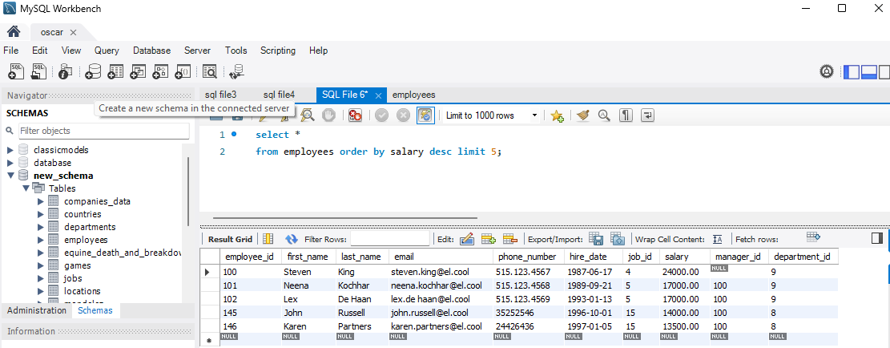
MYSQL:

19. Write a MySQL query to list the department ID and name of all the employees where the manager id is 90.
Sample table: (employees_data dataset)

MYSQL:

